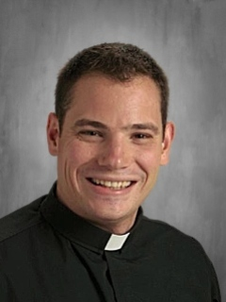Dear St. Joseph Parish,
In this Easter Season it is with great excitement that I introduce myself to you. My name is Fr. Timothy Schumaker and beginning June 18th, I will have the blessing to be your new priest administrator of St. Joseph Parish.
When I was in eighth grade my family moved to Mequon and we would from time to time attend St. Joseph. I remember feeling a warm, vibrant, faith-filled, and welcoming community. I am very much looking forward to no longer being a visitor of your parish family, but a member of it.
St. Joseph will mark my first experience as an administrator of a parish. I am honored to share this experience with you and look forward to this next chapter of my priesthood. I have to admit that my parents, who still live in Mequon, are also quite happy I am moving close to them.
I was ordained a priest in 2021 and am currently completing my first parish assignment at St. Dominic Parish in Brookfield as Associate Pastor. The three years spent at St. Dominic have been a gift and I am most grateful for my time there.
I would like to thank Fr. Nick for his guidance during this transition and for his two years at St. Joseph. As I am learning for the first time, it is always difficult to leave a parish family. I have known Fr. Nick for many years and his love for the St. Joseph community is apparent. I hope to continue the good work he has done and lean on what he has learned from this community.
I am anxious to meet each one of you and look forward to doing so on June 18th. Until then know of my prayers and may the Easter Peace and Joy continue to reign in your hearts this Easter Season!

With Joy and Thanksgiving,
Fr. Timothy Schumaker

